Ref. No. : 161SET-MOU-M/1604/02
Project : SCHNEIDER ELECTRIC TRAINING

Memorandum of Understanding (MOU)

between
EXCELLENCE CONSULTANTS INTERNATIONAL COMPANY LIMITED (ECCI)

and
LY TU TRONG TECHNICAL COLLEGE



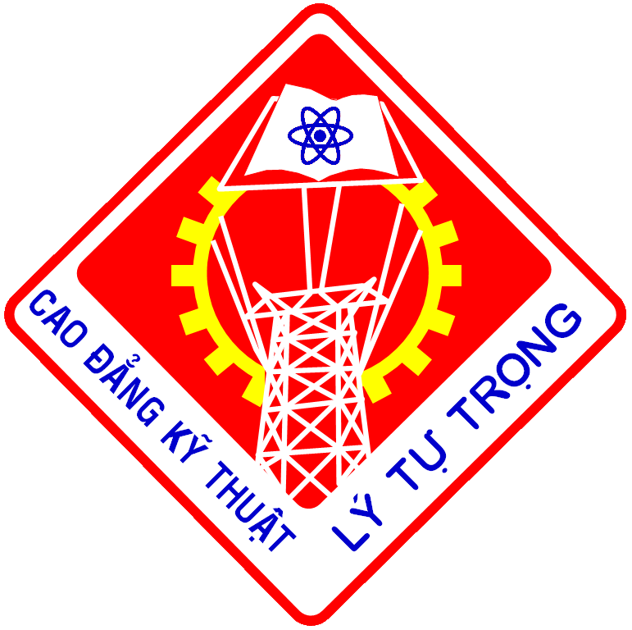
This MoU is made and deemed to be entered into between the following Parties by:

ASIA SOCIETY FOR SOCIAL IMPROVEMENT & SUSTAINABLE TRANSFORMATION (ASSIST)

Presented by

EXCELLENCE CONSULTANTS INTERNATIONAL COMPANY LIMITED (ECCI)
Address: 235-237-239-241 Cong Hoa Street, Ward 13, Tan Binh District, Ho Chi Minh City, Vietnam
Tel: (+848) 3948 3142
Fax: (+848) 3811 4701

Hereinafter referred to as “ECCI”

And

LY TU TRONG TECHNICAL COLLEGE
Address: 390 Hoang Van Thu Street, Ward 4, Tan Binh District, Ho Chi Minh City, Vietnam
Tel: (+84) 38441198
Fax: (+84) 38118 676
Hereinafter referred to as “LTTC”

This MOU shall be between the above Parties for the purpose of LTTC acting as an implementation partner to ECCI in respect to components of a Public Private Partnership Project (PPP) titled ELECTRIC TRAINING – Improving And Increasing Vocational Training Education, covered by a contract entered into between SCHNEIDER ELECTRIC and DEG (Deutsche Investitions – und Entwicklungsgesellschaft (mbH) of Cologne, Germany) in December 2015.

- Background of Agreement

The fast economic growth in Vietnam following the 1986 economic reform “Doi Moi” (renovation) has increased and intensified the demand for skilled labor. Still, the country’s vocational and technical education is lacking behind, therefore failing to meet the demand of skilled workers and technicians with practice oriented vocational qualifications.

ELECTRIC TRAINING project aims at improving and increasing vocational training education in Vietnam in the growing energy industry with a specific focus on electricity in order to ensure availability of skilled workforce in this specific industry. The project’s main target group are high school drop-outs and students from underprivileged backgrounds who shall be offered a chance for a vocational education leading to steady employment and/or entrepreneurship. The project will be executed in a close partnership with local institute - Ly Tu Trong Technical College, where a training center will be established to pilot the program - developing the curriculums, ensuring quality of trainers and increasing interest and awareness of new students for the education. The project aims at nationwide adaptation of the training program on a long run.

- Brief introduction about LTTC
LTTC was founded in 1986. This is one of main public colleges in HCM city and near by areas, providing multi-level and multidisciplinary training in various sectors. LTTC is located at 390 Hoang Van Thu Street, Ward 4, Tan Binh District, Ho Chi Minh City, on an area of 5 hectares with spacious learning environment, cool, calm, discipline, and friendly. The college has 29 technical training majors for total 10,000 students and an annual enrollment of 4000 students.

- Brief introduction about ASSIST & ECCI
Asia Society for Social Improvement and Sustainable Transformation, Inc. (ASSIST) is an international non-governmental capacity building organization with its headquarters in Philippines and the other offices in Vietnam and India. ASSIST has implemented over 50 developmental projects in about 13 countries in South Asia, ASEAN, China and Africa. These projects are funded by such international donors as European Union, UNIDO, UNEP, IFC, USAID, DEG, GIZ, SEQUA, ADB, among others.
ECCI Vietnam is a Vietnam branch of multinational company ECC International (ECCI) with headquarter in Manila, Philippines and other offices in Malaysia, Singapore, China, Indonesia and India. ECCI Vietnam is the leading process improvement solutions provider in Southeast Asia, focused on process consulting, automation solutions, and learning outsourcing services
On 22nd March 2016, ASSIST has authorized ECCI to be the representative for the Electric Training project in Vietnam. ECCI has been registered in Vietnam since 2010 and is now working under the field of management and training consulting services.
- Purpose of Agreement
This Memorandum of Understanding was signed between the parties mentioned above, in which LTTC is the beneficiary and co-partner of the project implementation whereas ECCI is the activity, finance and implementation management unit for this Public Private Partnership project which is named Electric Training and being carried out in three (03) years from 2016 to 2018. This project is mainly funded by German Development Bank (DEG – Deutsche Investitions - und Entwicklungsgesellschaft) and Schneider Electric Vietnam Ltd. Company with the total fund of 430,000 USD (in cash). The goal of this project is to establish two (02) training programs includes Basic Electricity and Sustainable Energy Management thereby improving and enhancing the proficiency of vocational instructors in Electrical training field through designing and developing the curriculums as well as providing laboratories for the beneficiary.
The training is to transfer Electrical training skills and for the local instructors, who is in charge of expanding the training courses of the center, which will be held in LTTC in two months time, one (01) month for Basic Electricity program and one (01) month for Sustainable Energy Management program. The project will train for at least 15 teachers, including 10 from LTTC and the remaining 5 from other vocational centers. The training program contents is designed by Schneider Electric Vietnam and the documents contents is provided by the experts of the Institute of Electrical and Energy Management (IEEM) of the Industrial Training Governmental Institute of the Ministry of Education of France and Schneider Foundation.
As for the Basic Electricity program, regular classes whose students are adolescents living in difficult circumstances, the project will support with the full cost of studying and living. As the official training center, LTTC will not charge any tuition fees for the Basic Electricity program. However, LTTC may charge some additional fees for Sustainable Energy Management courses depending on the school’s policy.

- Term of Agreement
With the project title Electric Training, ECCI and LTTC agree that the cooperation between the parties will promote the vocational training in schools to increase awareness and interest among students and teachers. To ensure accomplishment of the mentioned cooperation, ECCI and LTTC agree on the following terms and conditions:
5.1 ECCI shall
- Be responsible for Project Management to assure implementation of all project activities within timeline and quality. ECCI must inform LTTC for any change in timeline;
- Be responsible for inviting and paying experts from the Institute of Electrical and Energy Management of the Industrial Training Governmental Institute of the Ministry of Education of France and Schneider Foundation for teachers training purpose;
- Provide translators during the timeline of the teachers training courses;
- Provide all the machineries, equipment and materials to carry out the “Basic Electricity” and “Sustainable Energy Management” programs of the project;
- Decorate the laboratories with Schneider Electric Vietnam;
- Be responsible for paying experts from the Institute of Electrical and Energy Management of the Industrial Training Governmental Institute of the Ministry of Education of France and Schneider Foundation for providing training materials of “Basic Electricity” and “Sustainable Energy Management” programs purpose;
- Provide scholarships, school stationary and materials for students with difficult circumstances;
- Carry out evaluations after every training courses.

5.2. LTTC shall
- Cooperate and support ECCI in implementing project activities to ensure the project quality and schedule;
- Provide the information of person responsible for project management from LTTC;
- Provide at least 10 qualified teachers to participate in “Train the Teachers” course conducted by project;
- Provide at least one (01) full-time teachers for each “Basic Electrician” and “Sustainable Energy Management” course;
- Be responsible for reconstructing existing room within the consultancy of Schneider Electric Vietnam to set up laboratory;
- Be responsible for enrolling students and certificating for students graduated from the project training course;
- Cooperate with ECCI in organizing training courses “Basic Electrician” and “Sustainable Energy Management” in order to localize the knowledge transferred to students. For underprivileged students, LTTC will not charge any fees;
- Pay labour fee to teachers, who teach the training courses of project, with the minimum rate of contract lecturer (giảng viên thỉnh giảng);
- Support project team and ECCI in activities concerning cooperating with the government;
- Commit to maintain the training courses and the laboratories after the project closed.

- Confidentiality Agreement
The parties herewith undertake to treat confidentially all information that they obtain directly or indirectly from each other within the agreement. Confidential treatment means that the information obtained may not be made available to a third party and that the information may not be used for the parties’ economic purposes or for the purposes of a third party. The parties undertake to use the information obtained solely for the purpose stipulated in the preamble. Any use going beyond that purpose or the conveying of information to a third party requires the written consent of both parties.

- Amendments
Any changes, modifications, revisions, or amendments to this MOU which are mutually agreed upon by the parties to this MOU shall be incorporated by written instrument, executed, and signed by all parties to this MOU with the same approvals, certifications, submissions and other requirements applicable to the original MOU.

- Binding Effect
This MOU shall be binding upon the Parties and their heirs, successors and assign, including, but not limited to, third parties becoming affiliated with the parties through development, acquisition, merger or other form of contractual arrangement.

- Applicable Law
The Laws of Vietnam shall govern this MOU.

- Language
This MOU is composed in Vietnamese and English. In case of any discrepancy between the linguistic versions of this MOA or dispute, the English version will prevail, being the official version.

- Attachments
Annex 1: Program Content
Annex 2: Laboratory Layout

In circumstance of modification and addition for given activities, two parties must formally recorded discussion under a written form.
This MOU is made into six (06) original sets including three (03) Vietnamese copies and three (03) English copies. LTTC shall keep two (02) original Vietnamese and two (02) English sets and ECCI shall keep one (01) original Vietnamese and one (01) English set of equal validity. This MOU shall come into effect from the signing date, and shall automatically become liquidated upon the completion of all articles set forth in the MOU without any dispute.

For and on behalf of  ECCI | For and on behalf of  LTTC
Name : Arumugaraj Davitdurai Pandian  Position:  Date : | Name :  Position :  Date :

Annex 1
Program Content
The project will conduct three (03) training programs as below:
a) Basic Electricity Residential & Industrial for full-time class, which is hereinafter known as Program 1
b) Basic Electricity Residential & Basic Electricity Industrial for evening class, which is hereinafter known as Program 2
c) Sustainable Energy Management, which is hereinafter known as Program 3
These above programs will be designed and include the following information:
1. General information
Category | Time | Duration
Program 1 | Full time | 350 hours
Program 2 | Evening shift | 120 hours
Program 3 | Full time | 52 hours/ module

2. Program curriculum
2.1 Program 1 & 2 will cover the fields:
- Taking care of its own security
- Putting in place devices and apparatus in accordance with standard practice
- Posing pipes, brackets and wires, devices using the procedures, texts and regulations in force in accordance with standard practice
- Connecting different types of conductors
- Wiring a fire alarm, intrusion alarm, access control system under supervision
- Wiring a simple Industrial cabinet in accordance with standards practices
- Performing a measurement on an electric installation
- Identifying the source of simple troubleshooting

2.2 Program 3 consists of three (03) optional modules, which will cover the following fields:
Module 1: Designing a sustainable installation.
- Taking care of its own security
- Putting in place devices and apparatus in accordance with standard practice
- Wiring a domestic distribution board
- Choosing the right domestic equipment
- Wiring an industrial motor starter circuit
- Choosing the right equipment according to the load

Module 2: Low voltage electrical installation – Building. This module will cover the following fields :
- Identify the nature of the activities on the site regarding the interventions work (Without voltage or vicinity).
- Wiring and configure a VDI system
- Wiring a complete fire alarm, intrusion alarm, access control system
- Perform a measurements on electric installation (P, V, I, …)

Module 3: Industrial electricity and Automation
- Read and design Industrial wiring according to the specification given
- Wiring a PLC
- Wiring an electronic starter and a speed driver
- Set up basic PLC parameters
- Identify and set up sensors (Capacitive, Inductive, Optoelectronic, Mechanical)
- Perform test and measurements

Annex 2: Laboratory layout
2m
3m
1m
1m
1m
1m
5m
Basic Electricity Lab.
Module 1, 2, 3, 4 Lab.
1m
Situation Zone
Trainer room & Storage
Electrical Cabinet
4m
4m
1m
3m
8m
4m
3m
6m
Electrical Protection:
- Main protection MCB C64 + RCD 30 mA
- Triphases: MCB C32 (32A curve C) For Industrial Plugs
- Single Phase MCB C32 (32A curve C) For Industrial Plugs
- 5 * MCB C16 (16A curve C) For Domestic Plugs

Situation zone:
- See Situation zone document

Industrial Plug Tri-phases 230/440 V, 16 A, 3P + N + PE
Domestic Plug Single Phase 230V, 16 A, 1P + N + PE
Industrial Plug Single Phase 230V, 16 A, 1P + N + PE

Module 4, 5, 6 Lab

